Progress of TACS-2020
Team SHER
District LAYYAH

Activities under taken by Team Layyah;
- TACS team provided awareness on regarding Covid-19, Preventive measure and importance of social distancing.
- TACS team facilities poor Communities to register in Ehsaas emergency cash program, Ehsaas Rashan Program, Punjab Insaaf Imdad Portal.
- TACS team motivated Volunteer and MC’s members for awareness campaign and to register as Volunteer in Corona Tiger relief force

Roll of Mohallah Committees during Covid-19 Lock down Situation
Sr.No | Name of UC | Name Of MC’s | Focal Person | Beneficiaries’ Families | Activity
01 | Shah du khan | AL Taleem | Ghulam Fareed | 100 | Food Distribution
 |  | Roshan Taleem | Muhammad Rasheed | 70
02 | Kotla haji shah | Kotla haji shah | Muhammad Abbas | 80 | Food Distribution
03 | Sumra Nashaib | Umeed-e-Nao | Muhammad Sajid | 90 | Food Distribution
04 | Shah pur Dorata | Al haider | Nadar Abbas | 200 | Food Distribution
05 | Lohanch Nashaib | Lohanch Nashaib | Safdar Abbas | 100 | Food Distribution
06 | Saho wala | Al- saher | Muhammad aslam | 75 | Food Distribution
07 | 67 ML | Agahi | Mian Fazal Haq | 80 | Food Distribution
 |  | 67ML | Muhammad Asif | 70 | Food Distribution
08 | 112 ML | Shama | Ishtaiq Ahmad | 60

Roll of Mohallah Committees about COVID-19 Awareness program
Sr.No | Name of MC’s | Purpose | Initiative By
1- | Sumra Nashaib | To guide people in different UC’s about Covid-19  safety measures’  Social Distancing  Isolation & Quarantine  How to protect their children’s from Corona  Wash hands  Use of Mask and gloves  Take steps to help Needy people in this situation | MC’s and Volunteer’s Under Observation of TACS Staff.
2- | Shah pur Dorata
3- | Lohanch Nashaib
4- | Basti shah du khan
5- | Sahoo wala
6- | 67 ML
7- | Kotla haji shah
8 | 112 ML

TACS Team IT Support
TACS-SHER Team Layyah provided IT support to needy people to register them self’s on Govt. of Punjab and Federal Govt. Initiatives of Punjab Insaaf Imdad Portal, Ehsaas Rahsan Distribution Programme and Ehsaas Emergency Cash Programme by Prime Minister of Pakistan.
TACS- SHER team Layyah registered almost 890 persons from District Layyah on these Portals for to get them in Govt Corona relief fund Schemes..
Registration Details
Sr.No | Detail | ACHIVIEMENT FIGURES
01 | Registered on Punjab Insaaf Imdad Portal | 650
02 | Registered on Ehsaas emergency cash programme | 883
03 | Registered on Corona Tiger Relief Force register | 70
04 | Registered on Ehsaas Rashan Distribution Programme | 400

Few photographic evidence Distribution of Ration by Mohallah Committees & Volunteers
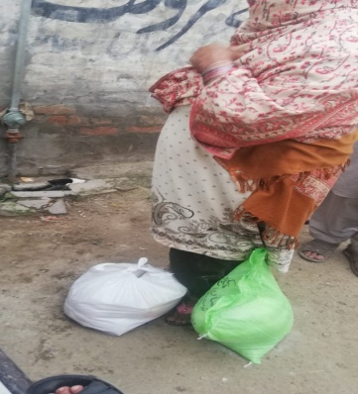
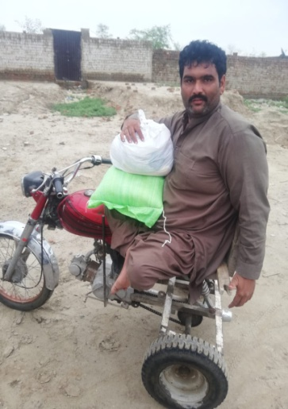
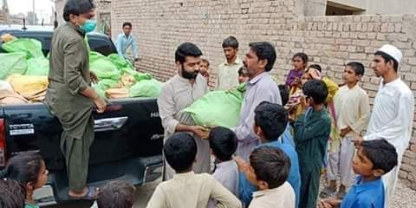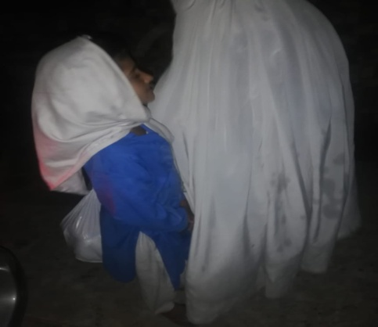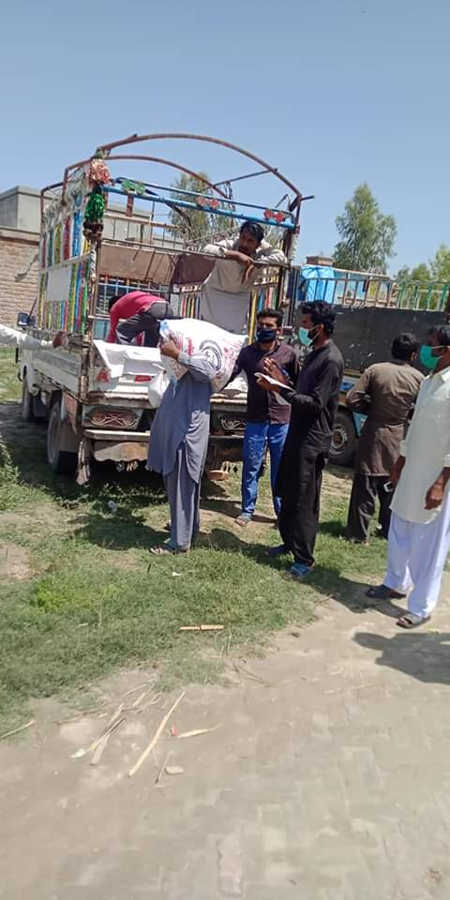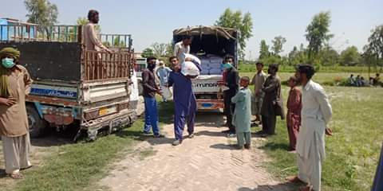
Rashan Distribution Initiative By SHER Layyah with Cooperation of Madarsaa Usman-o-Ali Layyah
With cooperation of Madarsaa syedna Usman-o-Ali, SHER LAYYAH took a step to distribute Rashan in needy and poor Families which are disturbed with situation of Covid-19 under Lock down by Govt. of Punjab. In almost 300 families completed Rashan distribution by SHER Layyah & Madarsaa and we are continuously doing our part to help poor families.
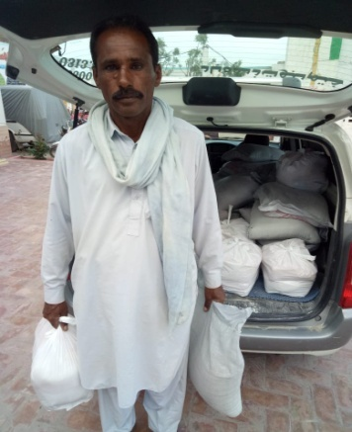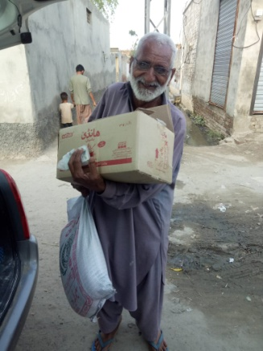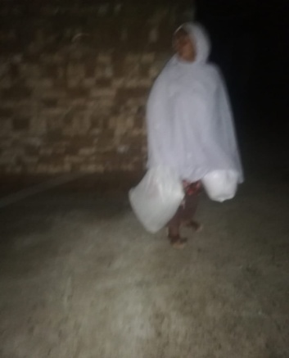
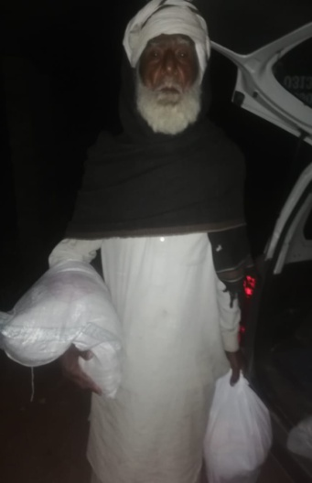
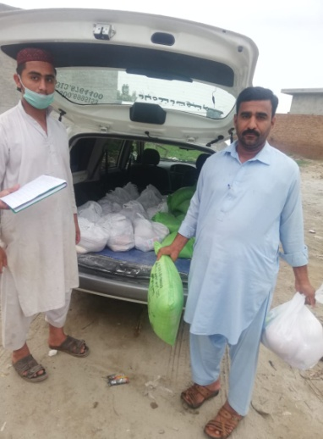
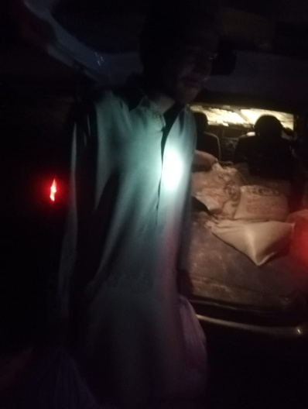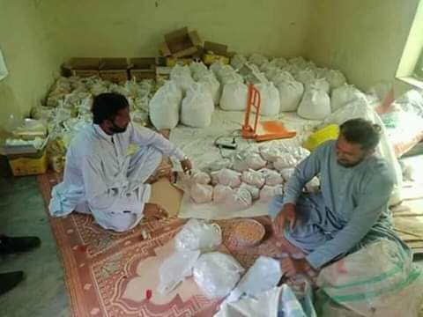
Agreement doc between SHER Layyah & Madarsaa Syedna Usman-O-Ali Layyah
